 



Database Programming with SQL 2-3: Comparison Operators Practice Activities

# Objectives

* Apply the proper comparison operator to return a desired result
* Demonstrate proper use of BETWEEN, IN, and LIKE conditions to return a desired result
* Distinguish between zero and the value of NULL as unavailable, unassigned, unknown, or inapplicable
* Explain the use of comparison conditions and NULL

# Vocabulary

Identify the vocabulary word for each definition below.

|  |  |
| --- | --- |
| ESCAPE | This option identifies that the escape characters should be interpreted literally |
| IS NULL | Condition tests for null values |
| BETWEEN | Displays rows based on a range of values |
| inclusive | Including the specified limits and the area between them; the numbers 1-10, inclusive |
| LIKE | Selects rows that match a character pattern |
| IN | Tests for values in a specified list of values |

# Try It / Solve It

1. Display the first name, last name, and salary of all Global Fast Foods staff whose salary is between $5.00 and $10.00 per hour.

SELECT first_name, last_name, salary

FROM f_staffs

WHERE salary BETWEEN 5 AND 10;

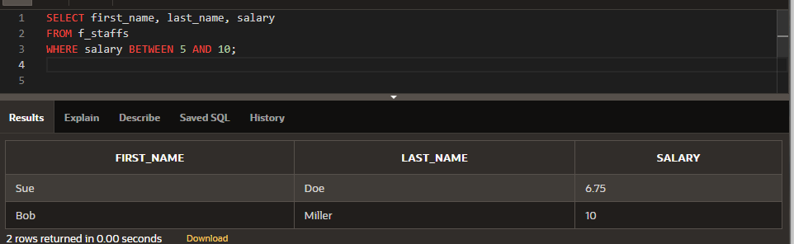

1. Display the location type and comments for all DJs on Demand venues that are Private Home.

SELECT loc_type, comments

FROM d_venues

WHERE loc_type = 'Private Home';

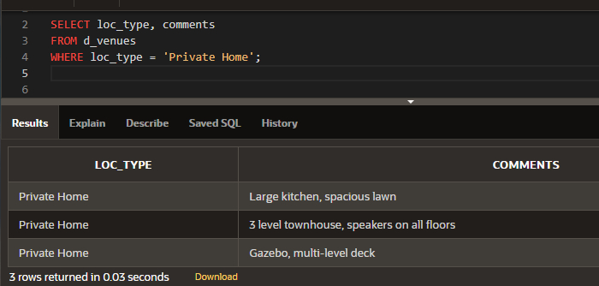

1. Using only the less than, equal, or greater than operators, rewrite the following query: SELECT first_name, last_name

FROM f_staffs

WHERE salary >= 20.00 and salary <= 60.00;

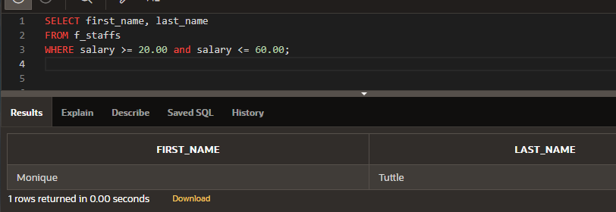

1. Create a list of all the DJs on Demand CD titles that have “a” as the second letter in the title.

SELECT title

FROM d_cds

WHERE title LIKE  '_a%';

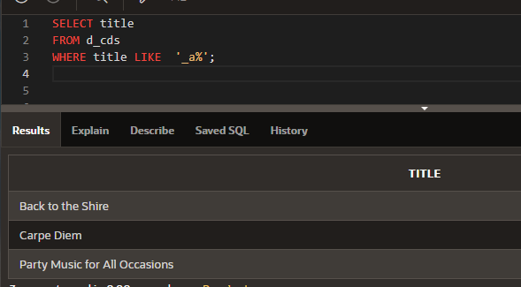

1. Who are the partners of DJs on Demand who do not get an authorized expense amount?

SELECT *

FROM d_partners

WHERE auth_expense_amt = 0 OR auth_expense_amt  IS NULL;

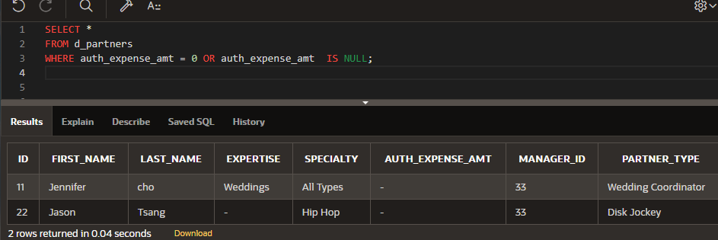

1. Select all the Oracle database employees whose last names end with “s”. Change the heading of the column to read Possible Candidates.

SELECT first_name  ||  ' '  || last_name  as "Possible Candidates"

FROM employees

WHERE last_name LIKE '%s';

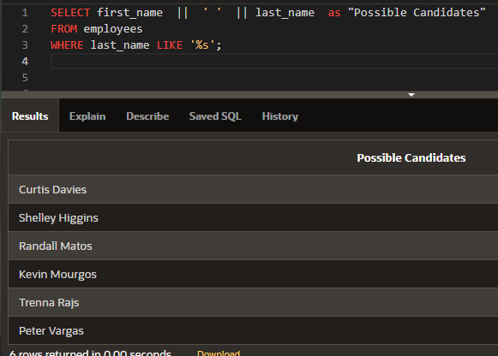

1. Which statement(s) are valid?
   1. WHERE quantity <> NULL;
   2. WHERE quantity = NULL;
   3. WHERE quantity IS NULL;
   4. WHERE quantity != NULL;
2. Write a SQL statement that lists the songs in the DJs on Demand inventory that are type code 77, 12, or 1.

SELECT title as "Song"

FROM d_songs

WHERE type_code IN (77, 12 , 1);

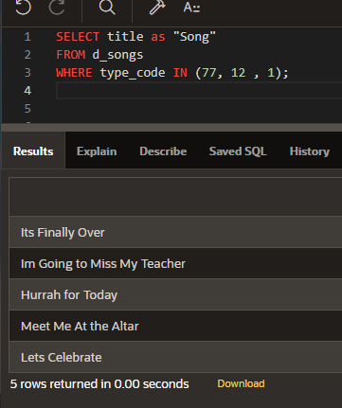

rights reserved. Oracle and Java are registered trademarks of Oracle and/or its affiliates. Other names may be trademarks of their respective owners.